Welcome!  Your CX system provides access to voice, fax, and email messages.  Before You Start  To access voicemail:  - On campus? 6-6245  - Off campus? 805-756-6245  Your mailbox number:  Gaining Access to Your Mailbox  - Call the on campus or off campus number.  - If necessary, press the key for triggering a subscriber log on (default = #).  - If prompted, enter your subscriber mailbox number.  - Enter your security code (or the default code, if your administrator has given you one). | Getting Started  If you want to… Enter  Listen to new messages 1  Record a message for another subscriber 2  Set User Options 3  Listen to saved messages 5  Listen to and recover messages marked for deletion (current session only) 7  Listening to New messages  If you want to… Enter  Listen to voice messages 1  Listen to fax messages 2  Listen to e-mail messages 3  Listen to messages from outside callers 4  Listen to messages from a specific mailbox 5  Listen to all messages 9 | While Listening to a Message  If you want to… Enter  Pause 1  Increase playback speed* 1 4  Decrease playback speed* 1 7  Forward 2  Backup five seconds 3  Delete 4  Save 5  Review 6  Skip to the next message 7  Reply 8  Skip ahead five seconds 9  Listen to message envelope information 0 0  While Replying to a Message  If you want to… Enter  Select mailbox* 1  Record 2  Transfer to extension* 3  Transfer to number* 4  Reply all* 5 | While Recording a Message  If you want to… Enter  Stop recording 2  Backup five seconds 3  Discard and start over 4  Skip ahead five seconds 9  After Recording a Message  If you want to… Enter  Send the message #  Continue recording 2  Discard and start over 4  Review 6  Request future delivery 0 1  Mark the message urgent 0 2  Restrict forwarding of the message 0 3  Request a return receipt 0 5  Leave number where you can be reached 0 8

Printing the VM Pocket Guide  This VM Pocket Guide has been produced as a completely editable Microsoft Word document. To produce it, do the following:  - Print the document double-sided. The margins of this document are set at .5”. If Microsoft Word produces a dialog box reading “The margins of this Document are set outside of the printable area,” select Yes.  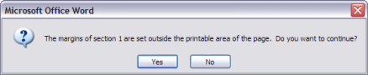 | - Cut the document along the lower dotted line.  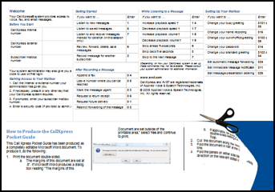 | - Fold the document in half at the center dotted line.  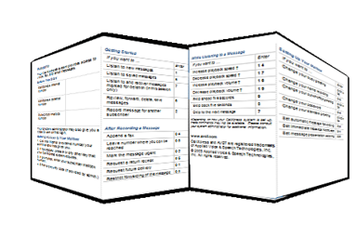  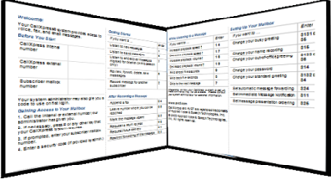 | - Fold the panels on either side back the opposite direction on the relevant dotted lines.

www.avst.com  1082-10210-13129  Rev 9.0.1.13.2  April 2018  © 2018 Applied Voice & Speech Technologies, Inc. (AVST). No part of this publication may be reproduced, transmitted, transcribed, stored in a retrieval system, adapted, or translated into any language in any form by any means without the written permission of AVST. Trademarks, service marks, products names, company names or logos of AVST are protected by trademark and other laws of the United States, as well as international conventions and the laws of other countries. Other such properties that are not owned by AVST may not be used without the express permission from their owners. | Getting Started  If you want to… Enter  Change immediate message notification* 3 1 1  Change daily reminder* 3 1 2  Change your busy greeting* 3 1 3 1 or 3 5  Change your standard greeting 3 1 3 2 or 3 4  Change your out-of-office greeting* 3 1 3 3 or 3 6  Change your security code 3 1 4  Change your name recording 3 1 5  Change language* 3 1 7  Change SMS notification* 3 1 8  * Depending on how your CX system is set up, these commands may not be available. Please consult your system administrator for additional information | While Listening to a Message  If you want to… Enter  Change a personal distribution list* 3 2 3  Set automatic message forwarding 3 2 4  Set message presentation ordering 3 2 5  Change message envelope settings 3 2 6  Change call screening* 3 3 1  Change call blocking * 3 3 2  Change extension-specific processing* 3 3 3  Change diverted call processing* 3 3 4 | Cal Poly Voicemail  Pocket Guide  For version 9.0 and above

 | Editing This Document  This document is an editable Microsoft word document.  Extensions, codes and text can be edited simply by clicking on the area to be edited, making changes and re-saving the document before production.  NOTE  We recommend saving the edited document with a new file name, so that a copy of the original document is preserved. | Changing the Logo  - Click on the logo image to select it.  - Do one of the following:  - In Word 2007 and later, right-click the logo and select Change Picture | From a file.  - In earlier versions of Word, select Insert | Picture.  - In the Insert Picture dialog box, browse to the new logo file and click the Insert button.  - The new logo replaces the older logo.  NOTE  The new logo should be no more than 2” wide and 2” tall. A *.png file is recommended.

